# Apache Jmeter localization Bug with Constant Throughput Timer

When using a Constant Throughput Timer component in Apache JMeter, bugs can occur when changing JMeter Localization Language.

Here the a JMX loaded and configured using English as JMeter language:

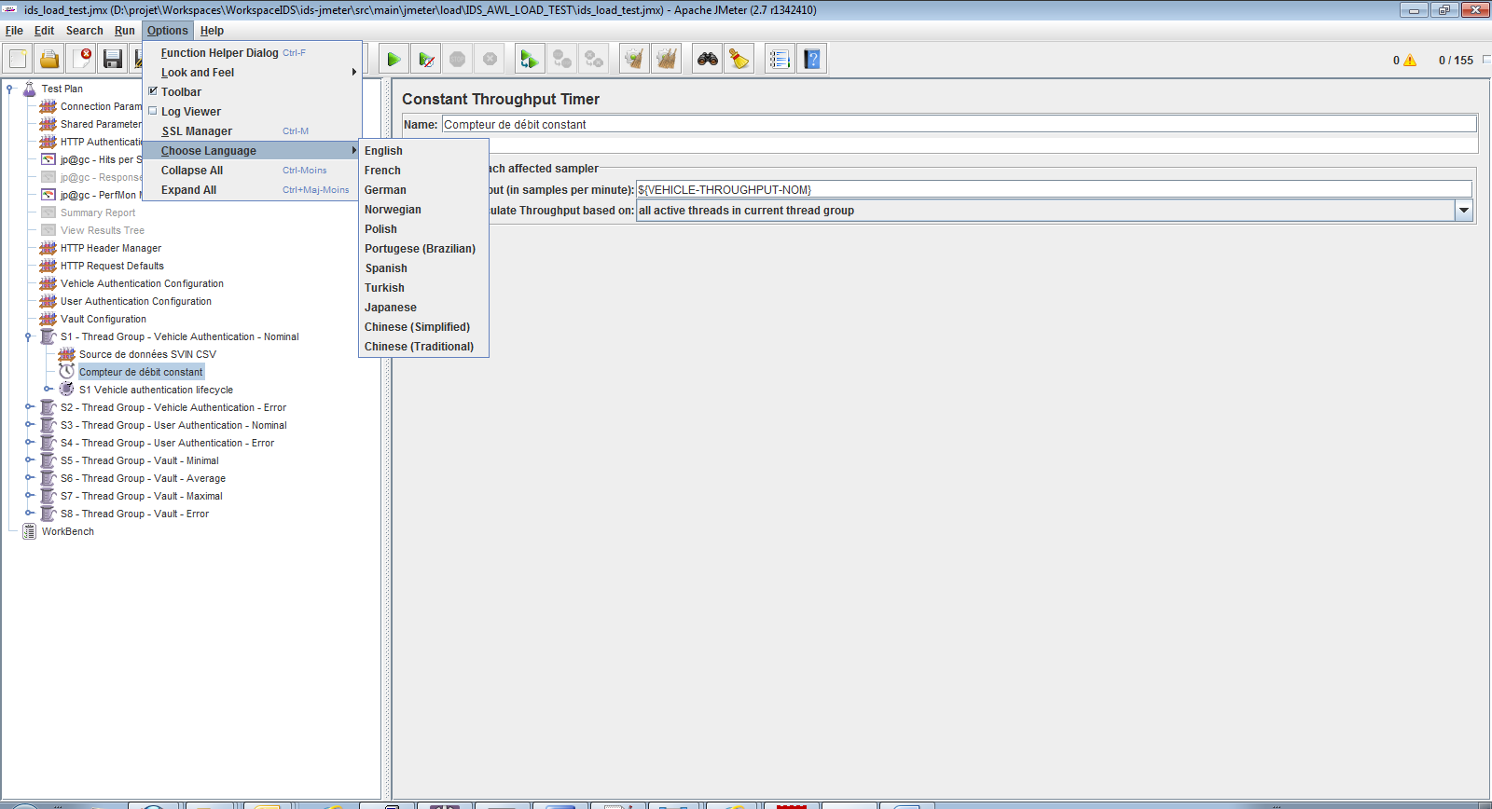

Figure 1 : JMX loaded in English

The parameter in red, defines how the component shall count requests:

* When value is "all active threads in current thread group", request number per second is calculated based on the activity of all thread running the Thread Group (all threads running the "S1 – ThreadGroup – Vehicle Authentication – Nominal" in this case).
  + This means that total request number for the thread group is equals to :

Request_number = ${VEHICLE-THROUGHPUT-NOM}

* When value is "this thread only", request number per second is calculated independently of other threads' activity.
  + This means that total request number for the thread group is equals to :

Request_number = ${VEHICLE-THROUGHPUT-NOM} * ${VEHICLE-THREAD-NOM}

In our case, the correct value is "all active threads in current thread group", this way, increasing threads number don't modify the number of requests executed. But a too small number of threads could limit this number of request.

Now, we just switch JMeter language:

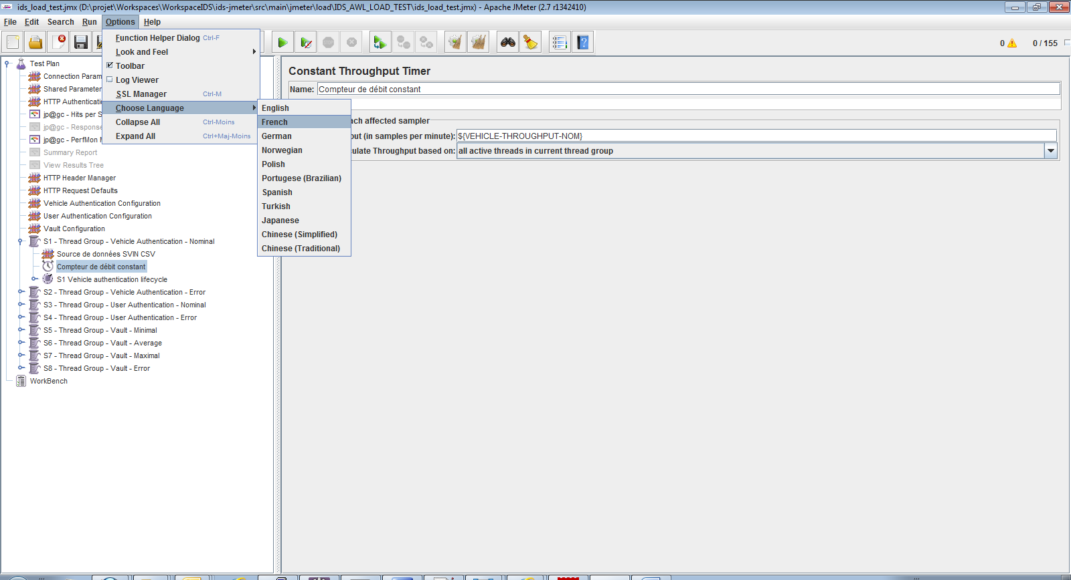

Figure 2 : Before switching language

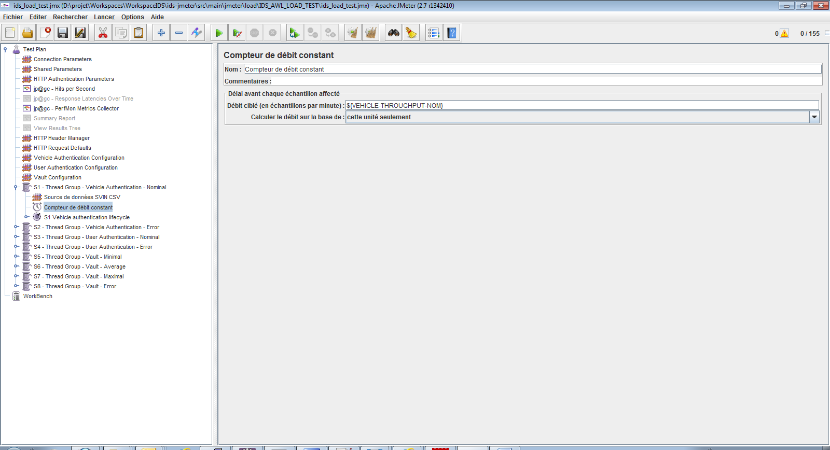

Figure 3 : After switching language

The value has changed when changing language, and even if one switch back to English, the value "this thread only" is kept.

The solution is to always load JMX files using Constant Throughput Timer using English language, because when executing a JMX in NON GUI Mode, JMeter always run with the English language.